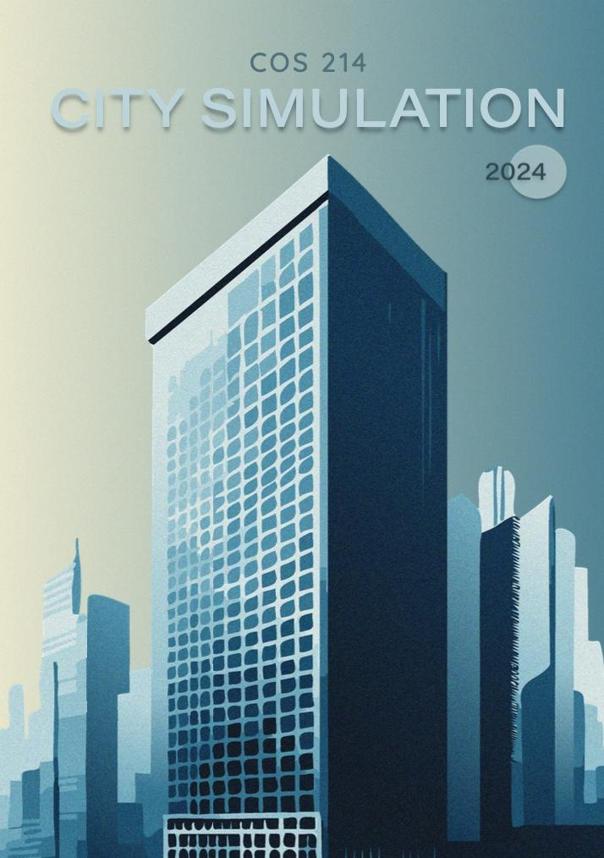



COS 214 Project Report

Group name: idk

(Nickname: Arrays of Sunshine)

u23587832 Hannah Koorbanally u23673941 Louise Bruwer u23530996 Kiara Hodgson

u23605376 Brendan du Plooy u21439631 Euan Botha u21437883 Nolan Kühn u23782219 Ruan le Roux

GITHUB REPOSITORY:

<https://github.com/COS214-Project-2024/idk>

LINK TO DOCUMENT:

<https://docs.google.com/document/d/1w2eHsOXzge7_VIquZCeK1Lx0pm3v5aoK9sUKoSMN8PU/edit?usp=sharing>

**Table of Contents**

**Section 1 : Research Brief 4**

1. Urban Development 4

2. Key Principles for City Management 4

**3. Role of Various Components In The City 4**

3.1 Buildings 4

3.2 Utilities 4

3.3 Transportation 4

3.4 Citizens 5

3.5 Government 5

3.6 Resources 5

3.7 Taxes 5

3.8 City Growth 5

4. Influence on design: 6

4.1 Utilities 6

4.2 Transportation 6

**Section 2: Design Pattern Application Report 7**

1. Iterator 8

2. Composite 9

3. Factory Method 10

4. Prototype 10

5. Mediator 10

6. Template Method 10

7. Strategy 11

8. State 11

9. Chain of Responsibility 12

10. Command 13

# 

# Section 1 : Research Brief

### Urban Development

Urban development transforms cities to drive economic & social growth. It focuses on improving living standards while addressing environmental concerns that arise from high population density. Key goals include enhancing quality of life through accessibleservices, housing & efficient transportation. Government, S. (2024)

### Key Principles for City Management

We found particularly relevant the principles of Acquiring sufficient funding (which includes financing running costs, as well as levying taxes) as well as that of Accountable governance, as per Nusca, A. (2024). Our government will be made to be as efficient and have as positive of an impact on citizens as possible.

### Role of Various Components In The City

### Buildings

Buildings serve multiple roles in a city. Residential properties, for example, house citizens, influencing their satisfaction and contributing to economic development. While each building type has a primary function (e.g., providing space for business, production, or residence), it also impacts the city's economy by contributing to GDP (Architecture Courses, 2024).

### Utilities

According to the Council of Scientific and Industrial Research (CSIR), residential utilities support domestic needs by providing resources like electricity and materials, while collective services handle waste management and sewer systems. Maintaining these utilities is crucial for citizen satisfaction and efficient public services.

### Transportation

Many factors can influence the method of transport citizens take. These factors include traffic, cost of vehicles/travel & the time taken to travel. The time taken for travel, in particular, may impact the citizen satisfaction of the city. Both private and public transportation varies depending on the given scenario. Factors such as traffic, cost of vehicle for public and private ownership and the time of travel influence which method is most efficient to travel across the city. Transit, P. (2021)

The transportation component is used within our system to influence factors such as citizen satisfaction, impact from a given scenario (car accident) and the generation of income from public modes of transport (impact on Bank and Government). The transportation section therefore has an economic, functional and qualitative role based on the effective management of the city.

### 

### Citizens

The concept of “citizen-centricity” came up in our research. Thisconcerns the prioritising of citizens’ demands in the designing and delivery stages of public services (Berntzen et al., 2016; Kamalia & Nor, 2017)

### Government

From our research, the government manages all aspects of the city. Examples are managing citizen satisfaction and welfare by ensuring residents have services & adequate housing, as well as Resource Management, where local governments are key managers of essential services like water & energy. Hoeflich de Duque, S. (2023)

### Resources

Urban areas depend heavily on resources to support their populations and activities. However, rapid urbanisation drives up resource consumption, complicating efforts to uphold sustainability principles. Therefore, effective resource management is essential for achieving sustainable urban development, focusing on maximising resource use while minimising waste and environmental impact. Zucaro, A., Maselli, G. and Ulgiati, S. (2021)

### Taxes

Taxes play a key role in how residents feel about their government and their own finances. Changes in tax rates affect people's bank accounts and their satisfaction with public services. There’s often a gap between what citizens want from their local government and what they’re willing to pay in taxes. When people see improvements in services that match their tax dollars, it boosts their overall happiness and financial situation. Glaser, M. A., & Hildreth, W. B. (1999)

### City Growth

Population growth significantly impacts taxes by increasing the demand for essential services like housing. As cities expand, they may need to raise tax rates or introduce new taxes to fund these services. On the other hand, a larger population can also broaden the tax base, potentially allowing for lower rates. Bahl, R., Holland, D. & Linn, J., (2015)

### Influence on design

Our government was made to be as efficient and have as positive of an impact on citizens as possible.

References

* Government, S. (2024) *Urban development*, *Portal GOV.SI*. Available at: https://www.gov.si/en/policies/environment-and-spatial-planning/prostor-2/urban-development/ (Accessed: 29 October 2024).
* Korppoo, K. (2015) *Designing game analytics for a city-builder game*, *Trepo*. Available at: https://trepo.tuni.fi/handle/10024/97480 (Accessed: 22 October 2024).
* Nusca, A. (2024) Four principles of Effective City Management, ZDNET. Available at: https://www.zdnet.com/article/four-principles-of-effective-city-management/ (Accessed: 22 October 2024).
* Villagomez, E. (2023) *S101s - describing building types: Why they matter*, *Spacing Vancouver*. Available at: https://spacing.ca/vancouver/2023/09/11/s101s-describing-building-types-why-they-matter/ (Accessed: 22 October 2024).
* Transit, P. (2021) Public vs. private transportation: Advantages & Disadvantages, Safe and Reliable Bus Charter Rentals in Ventura County. Available at: http://www.pegasustransit.com/post/public-vs-private-transportation-advantages-disadvantages (Accessed: 28 October 2024).
* Hoeflich de Duque, S. (2023) *Sustainable development through local governments*, *Urbanet*. Available at: https://www.urbanet.info/local-governments-sustainable-urbanisation/ (Accessed: 29 October 2024).
* Zucaro, A., Maselli, G. and Ulgiati, S. (2021) *Insights in Urban Resource Management: A comprehensive understanding of unexplored patterns*, *Frontiers*. Available at: https://www.frontiersin.org/journals/sustainable-cities/articles/10.3389/frsc.2021.807735/full (Accessed: 29 October 2024).
* Glaser, M. A., & Hildreth, W. B. (1999). Service Delivery Satisfaction and Willingness to Pay Taxes: Citizen Recognition of Local Government Performance. *Public Productivity & Management Review*, *23*(1), 48–67. <https://doi.org/10.2307/3380792>
* Bahl, R., Holland, D. & Linn, J., (2015). *Urban growth and local taxes in less developed countries*. Available at:<https://scholarspace.manoa.hawaii.edu/server/api/core/bitstreams/4b852e95-4d3b-4c3c-a9ba-e166f883d452/content> [Accessed 29 Oct. 2024]
* Architecture Courses (2024) *Building Types*. Available at:<https://www.architecturecourses.org/learn/building-types> (Accessed: 2 November 2024)

# Section 2: Design Pattern Application Report

## **Iterator**

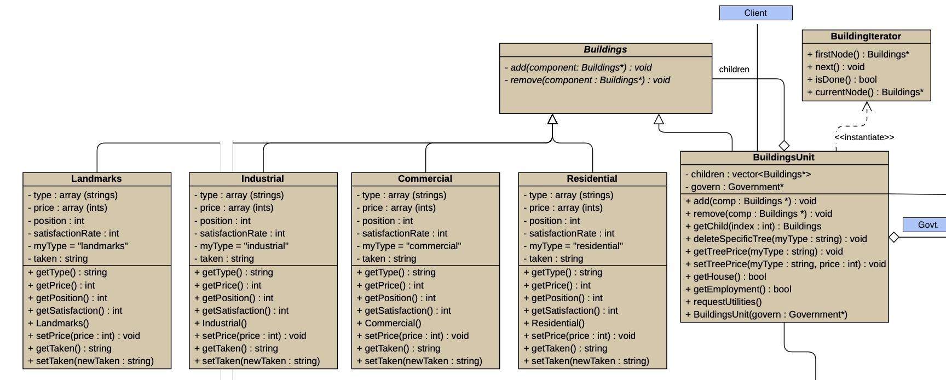

## **Composite**

**

## 

## **Factory Method (done)**

## 

## **Prototype (done)**

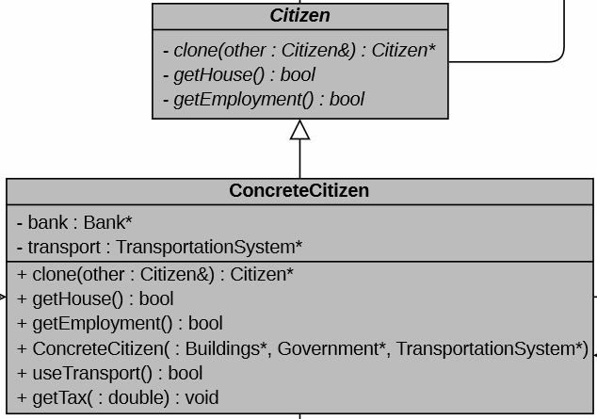

## **Mediator**

***Screenshot of this pattern in the big class UML***

## 

## **Template Method (done)**

Transport

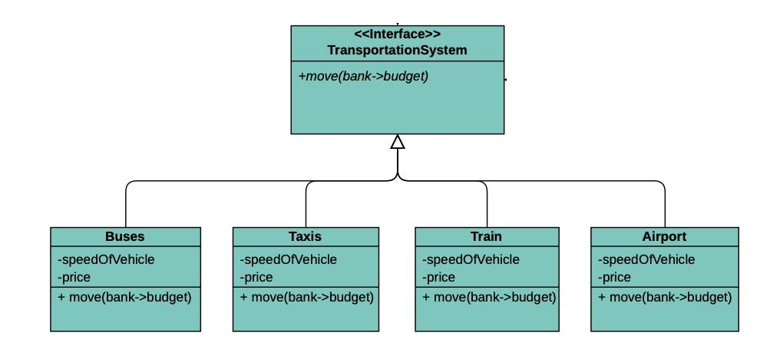

## City Growth

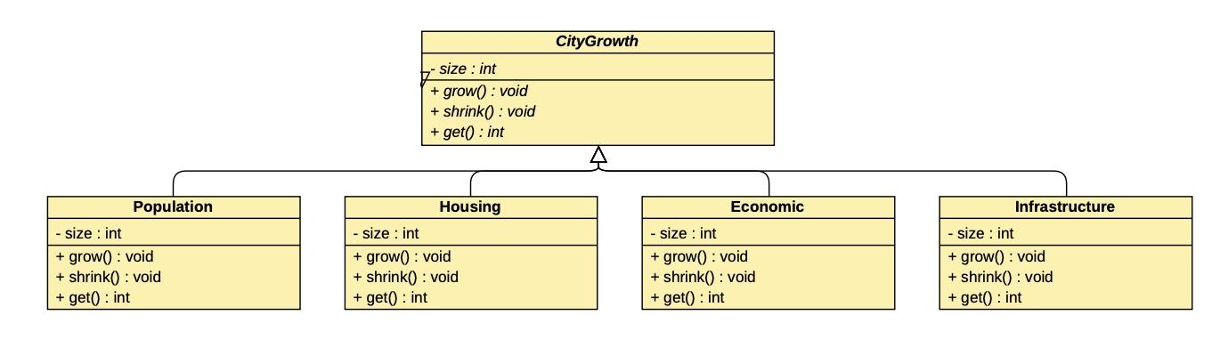

## **Strategy (done)**

***Screenshot of this pattern in the big class UML***

## **State (done)**

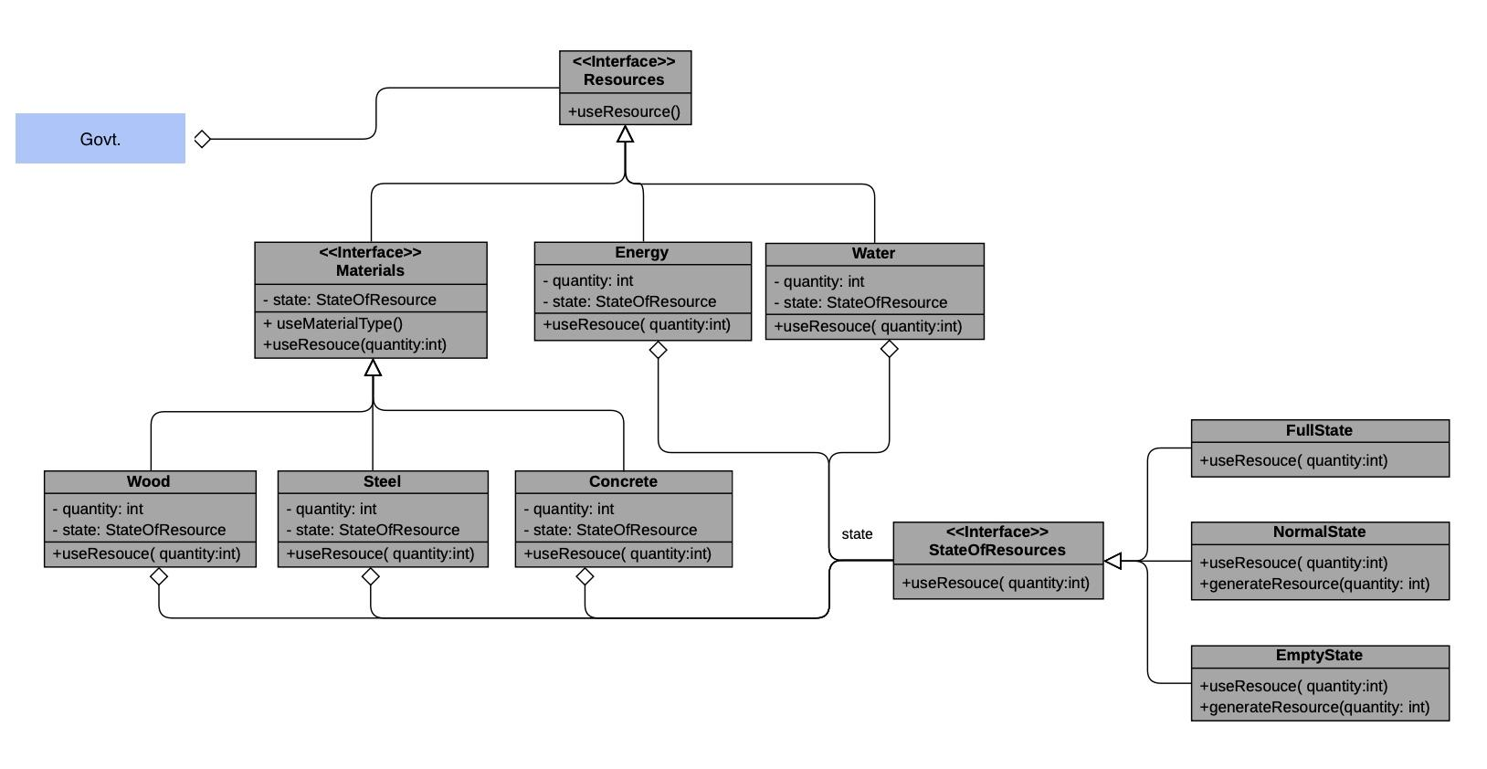

## **Chain of Responsibility (done)**

.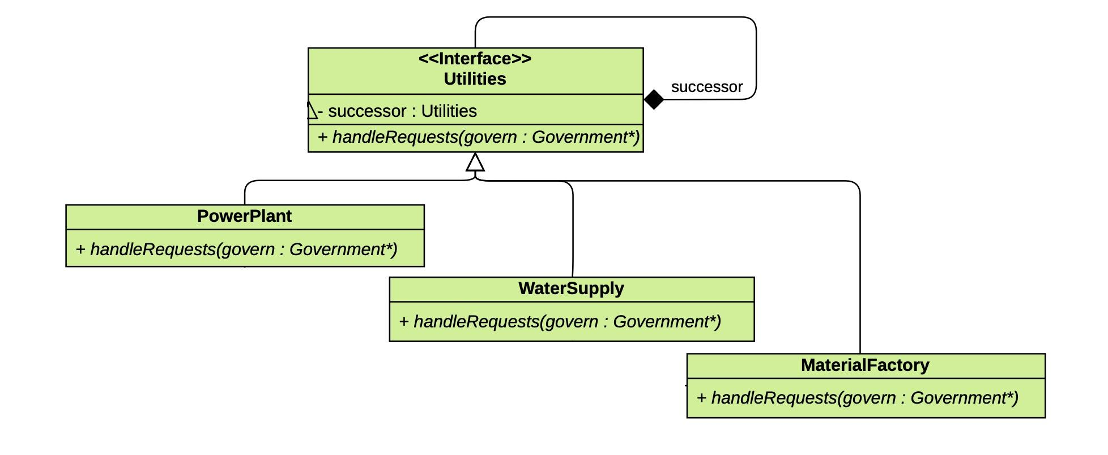

## 

## **Command**

## 

## 